ManuConnect Release - 2021.02.22
Release Date | 22 Feb 2021
Core Installer | 7.0.10222.770
Installer Suite | 7.0.10222.1145

Overview
Today's release contains various defect fixes for ManuConnect. There is no VO API item.

Defect Addressed
Defect | Client No. | Category | Summary | Release Notes
MLU-969 | 10953 | Admin GUI | [CDTASMU-10953] Plan Name and Billing Group Name Character limit | Increased the name and description character limit to match VO4 128 characters on the following pages:  - Rate Group  - Client  - Client Benefit  - Client Benefit Option  - Client Benefit Maximum Definition  - Client Plan  - Client Plan Revision  - Client Plan Benefit  - Client Plan Benefit Option
MLU-968 | 10952 | Admin GUI | [CDTASMU-10952] PBO: Post-Calculation Premium Adjustment field is missing: | Added the "Post-Calculation Premium Adjustment" field to the Client Plan Benefit Option UI.  MLU-968
MLU-967 | 10951 | Admin GUI | [CDTASMU-10951] Link Option: Missing fields for option names | Modified Client Plan Benefit Option UI to display the link name when adding links.
MLU-966 | 10950 | Admin GUI | [CDTASMU-10950] Apply date not feeding appropriately for newly created records | Implemented Employed Date, Apply Date & Effective Date with default value from the Apply Date on member add.
MLU-965 | 10948 | Admin GUI | [CDTASMU-10948] Global Rates are not displaying when trying to change plan benefit rate group links using ‘Use Global Rates’ check box. | Fixed the global rates to display when the "use global rates" check box is selected:  **Use Global Rates Checked:**  MLU-965-1  **Use Global Rates Unchecked:**  MLU-965-2
MLU-962 | 10939 | No subsystem | [CDTASMU-10939] Next Bill Date field is not auto-populating as it does in VO4 currently today | Pre-populated the "Next Bill Date" with the "Effective Date" when adding a new client billing group.
MLU-961 | 10931 | Admin GUI | [CDTASMU-10931] Navigation of Bill Status tab defaults the user to a different tab than it should | Navigation from the location "Billing Status" tab will not default tabs on the client or any other level.
MLU-960 | 10929 | No subsystem | [CDTASMU-10929] Plan members are listed twice in the Location/Class listing duplicating members | Prevented client / location / class active members from displaying duplicate records when client plan revisions exist with different plan name or plan number.
MLU-959 | 10926 | Admin GUI | [CDTASMU-10926] Underwriter data not available for selection for new client & not displayed for existing clients | Fixed Branch Code & Underwriter fields so that values are committed to the database.
MLU-958 | 10921 | Self-admin Billing | [CDTASMU-10921] VO7 UAT: Receive 'Cancelled - invalid file' Error When Uploading a File in Loader Utilities (Premium Statement Loader) | This is a Chrome specific issue - we have fixed the resolving of the name of the uploaded file, which was empty and causing the error.
MLU-943 | 10868 | Admin GUI | Client Menu Navigation Enhancements | Fixed navigation within the client menu to ensure that post, commit and undo (of new or existing records) will maintain the appropriate page navigations.
MLU-924 | 10848 | Accounting | [CDTASMU-10848] Transaction Register - Location Search Screens | Retain search criteria in the account search screen.

Screen Shots

MLU-968

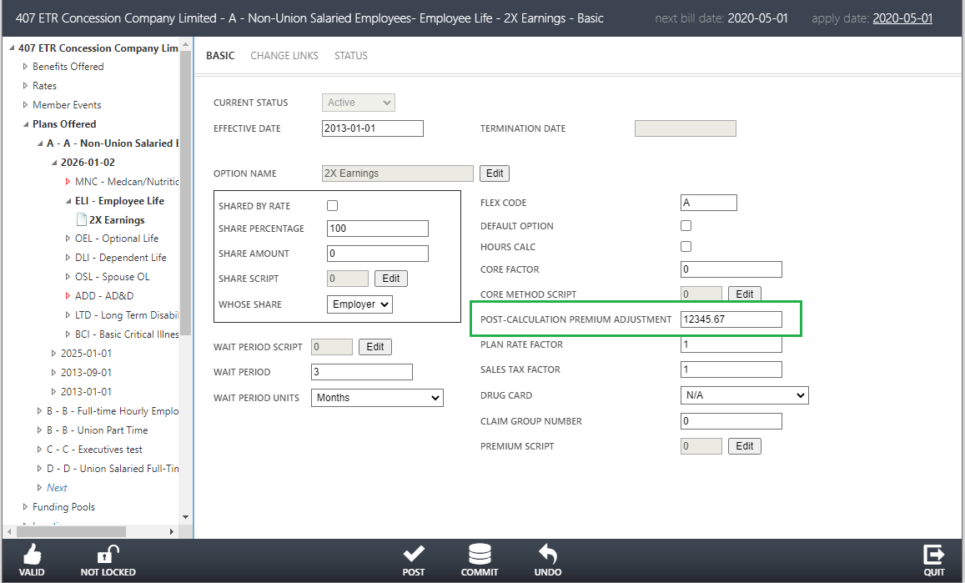

MLU-965-1
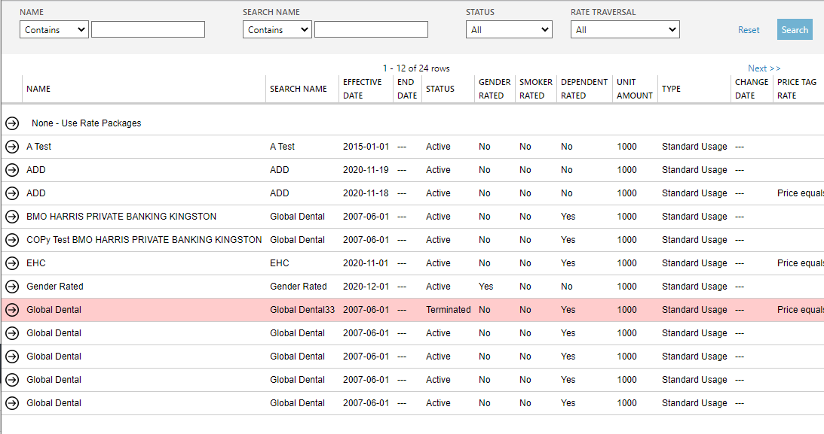

MLU-965-2
